UNITED STATES
SECURITIES AND EXCHANGE COMMISSION
Washington, D.C. 20549

Form 8-K

CURRENT REPORT
Pursuant to Section 13 or 15(d) of the Securities Exchange Act of 1934

Date of Report (Date of earliest event reported): May 13, 2022

NATURAL ALTERNATIVES INTERNATIONAL, INC.
(Exact name of registrant as specified in its charter)

Commission File Number: 000-15701

Delaware |  | 84-1007839
(State or other jurisdiction of |  | (IRS Employer
incorporation) |  | Identification No.)

1535 Faraday Avenue, Carlsbad, CA 92008
(Address of principal executive offices, including zip code)

760-736-7700
(Registrant’s telephone number, including area code)

(Former name or former address, if changed since last report)

Check the appropriate box below if the Form 8-K filing is intended to simultaneously satisfy the filing obligation of the registrant under any of the following provisions:

☐ | Written communications pursuant to Rule 425 under the Securities Act (17 CFR 230.425)

☐ | Soliciting material pursuant to Rule 14a-12 under the Exchange Act (17 CFR 240.14a-12)

☐ | Pre-commencement communications pursuant to Rule 14d-2(b) under the Exchange Act (17 CFR 240.14d-2(b))

☐ | Pre-commencement communications pursuant to Rule 13e-4(c) under the Exchange Act (17 CFR 240.13e-4(c))

Securities registered pursuant to Section 12(b) of the Exchange Act:

Title of each class | Trading Symbol(s) | Name of each exchange on which registered
Common | NAII | NASDAQ

Indicate by check mark whether the registrant is an emerging growth company as defined in Rule 405 of the Securities Act of 1933 or Rule 12b-2 of the Securities Exchange Act of 1934.

Emerging growth company ☐

If an emerging growth company, indicate by check mark if the registrant has elected not to use the extended transition period for complying with any new or revised financial accounting standards provided pursuant to Section 13(a) of the Exchange Act. ☐

ITEM 7.01 REGULATION FD DISCLOSURE.

The Company has updated its investor presentation on its website. The presentation can be found on the investor relations tab of the website at https://www.nai-online.com/our-company/investors/ . A copy of the Investor Presentation is attached hereto as Exhibit 99.5 and incorporated by reference herein.

On May 13, 2022, NAI issued a press release announcing its third quarter financial results, and the addition of an updated investor presentation to its website. A copy of the press release is attached hereto as Exhibit 99.6 and incorporated by reference herein.

ITEM 9.01 FINANCIAL STATEMENTS AND EXHIBITS.

(d) Exhibits.

99.5 | Investor Presentation May 13, 2022

99.6 | NAI Press Release issued on May 13, 2022.

104 | Cover Page Interactive Data File (embedded within the Inline XBRL document)

SIGNATURES

Pursuant to the requirements of the Securities Exchange Act of 1934, the registrant has duly caused this report to be signed on its behalf by the undersigned hereunto duly authorized.

 | Natural Alternatives International, Inc.
 | a Delaware corporation
Date: May 13, 2022 | By: | /s/ Mike Fortin
 |  | Mike Fortin, Chief Financial Officer

- 2 -
Exhibit 99.5

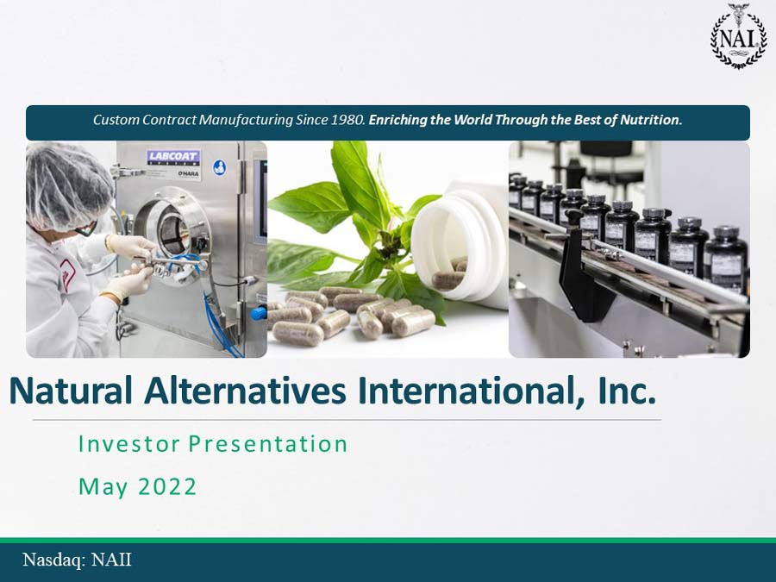

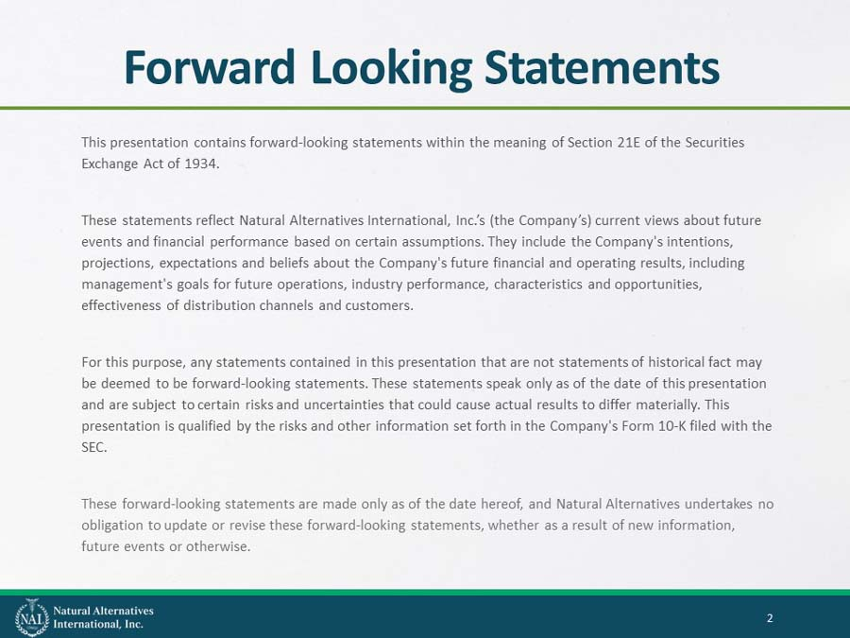

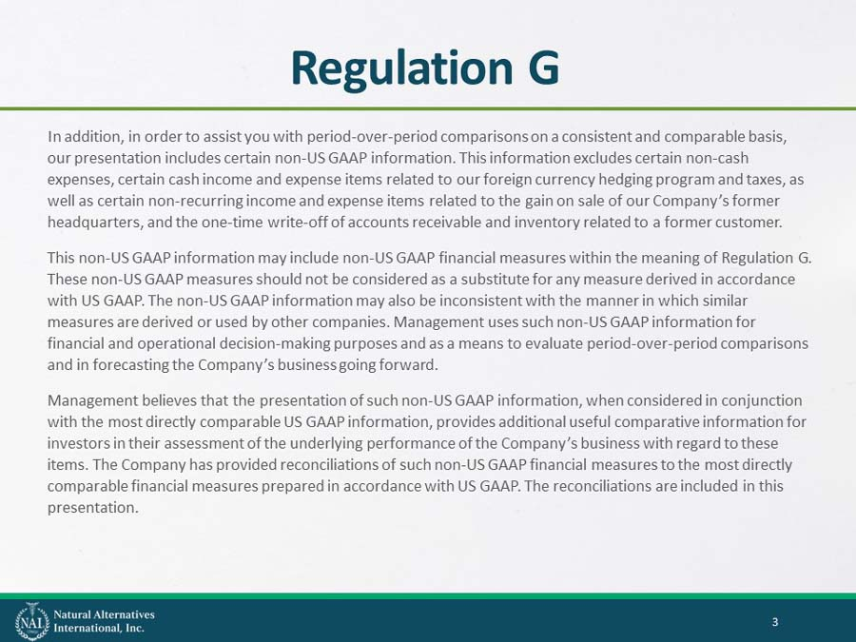

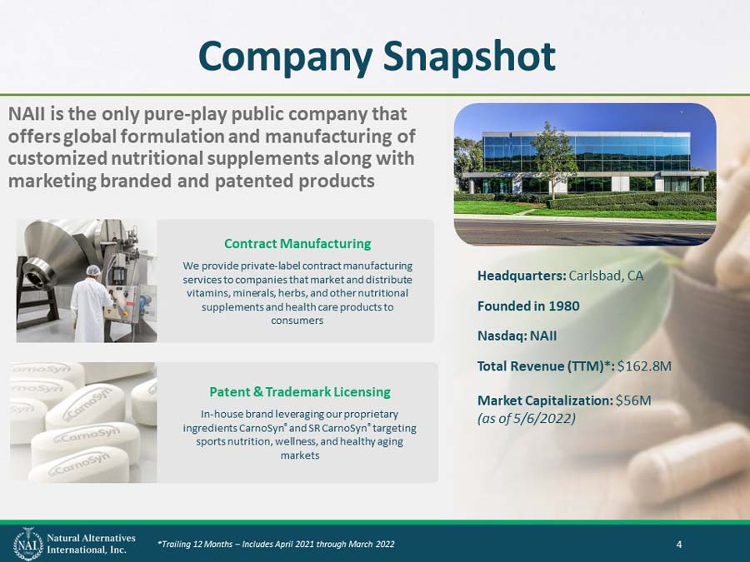

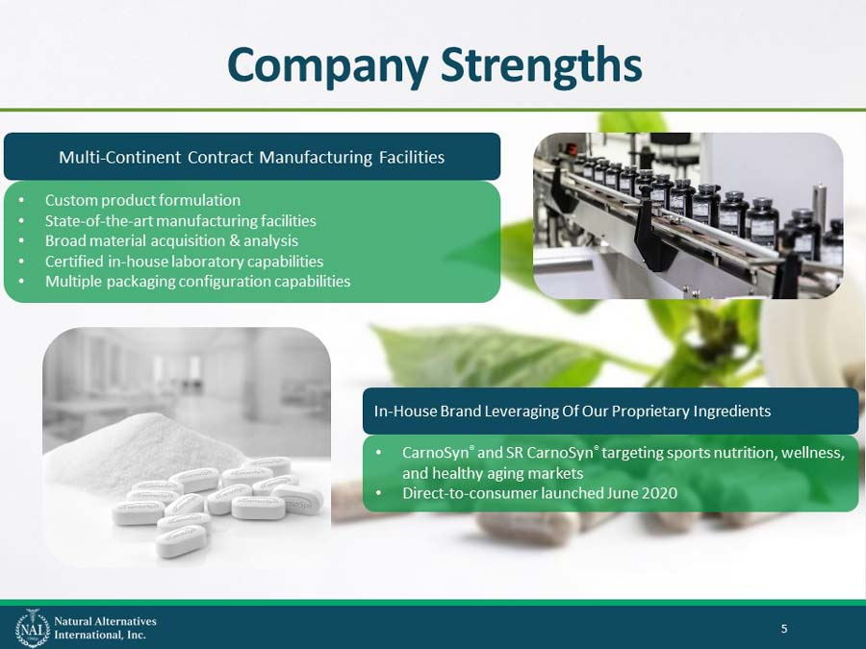

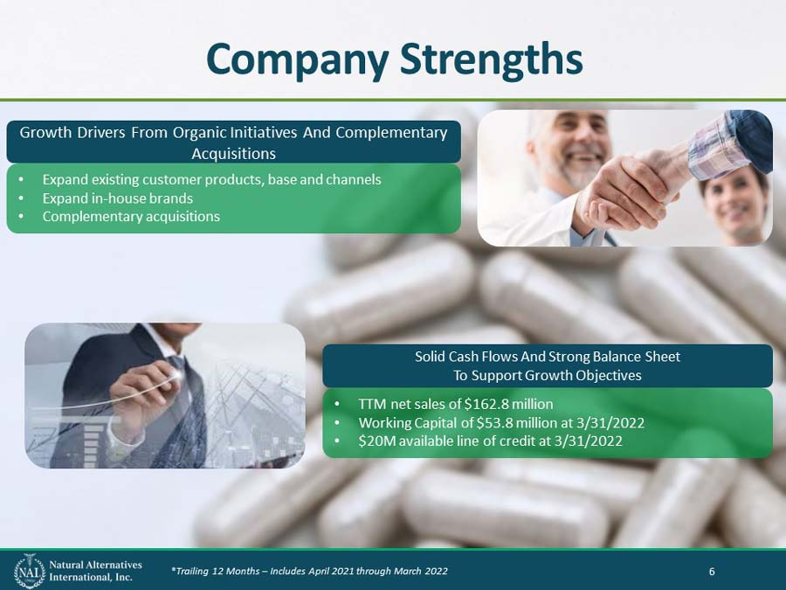

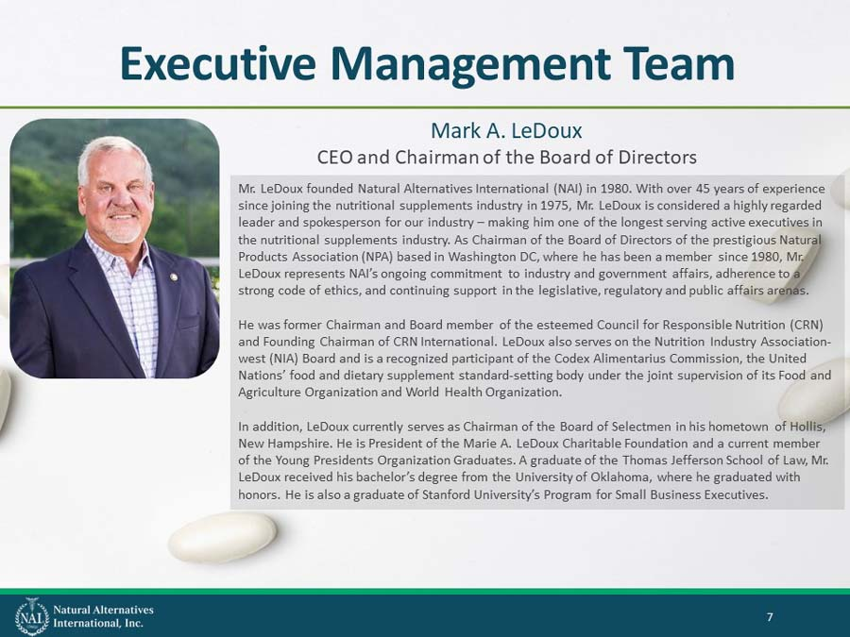

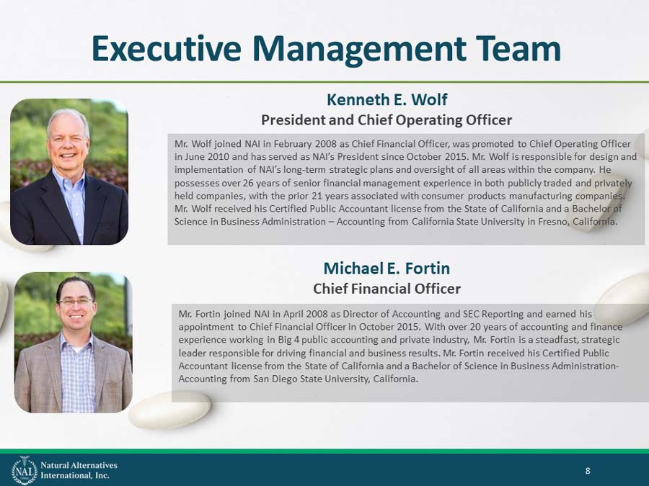

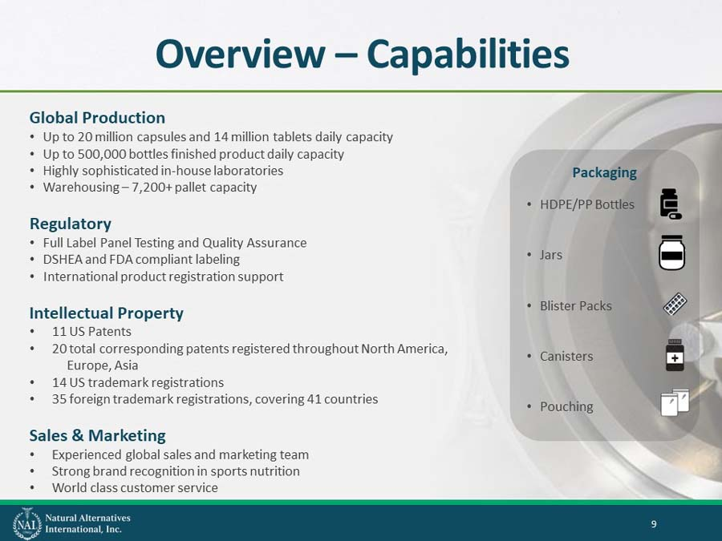

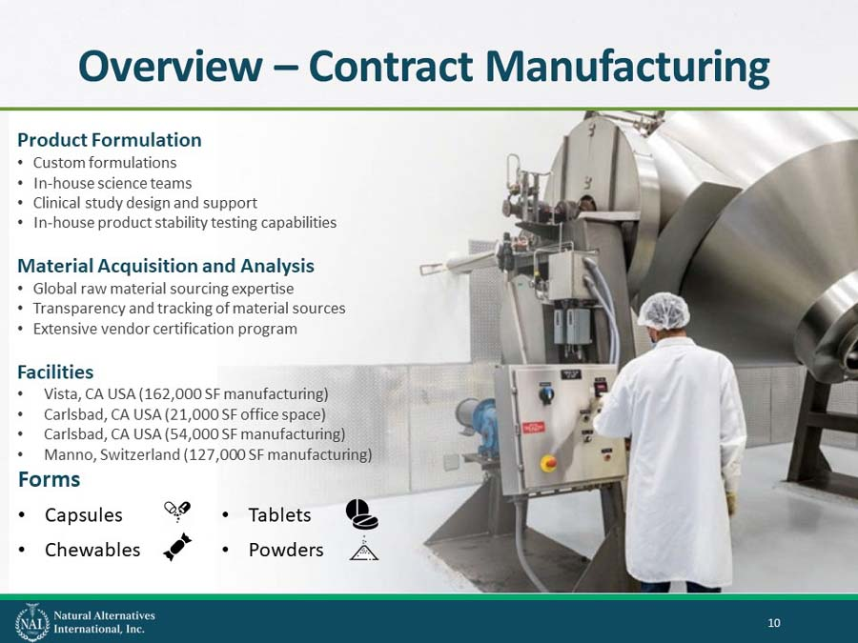

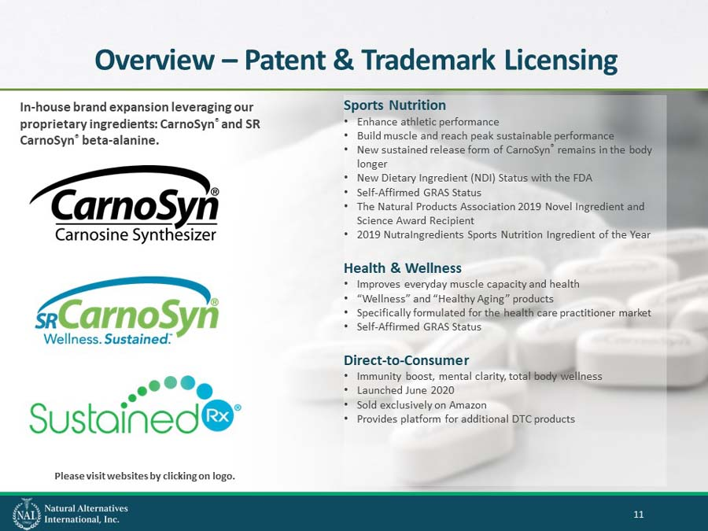

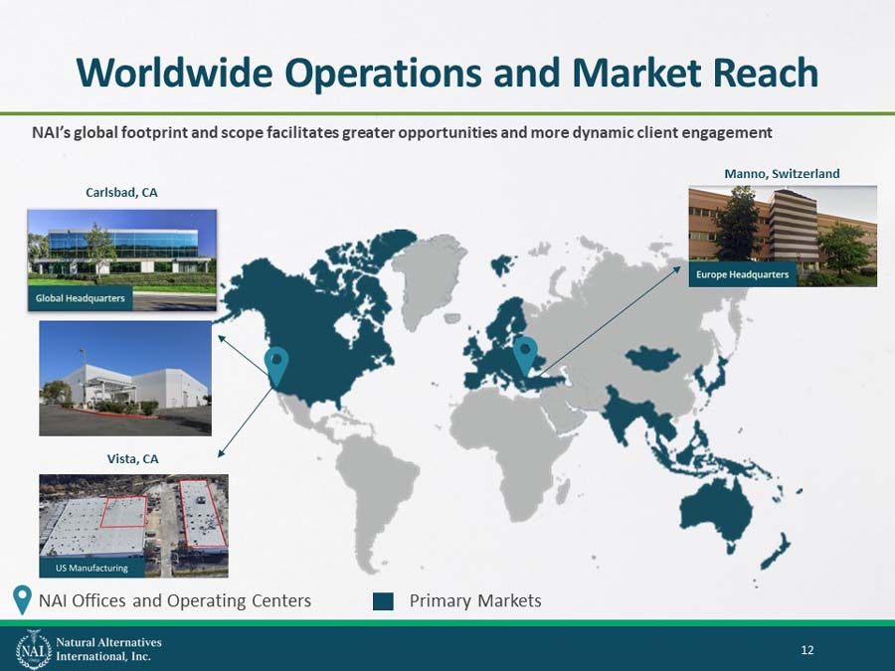

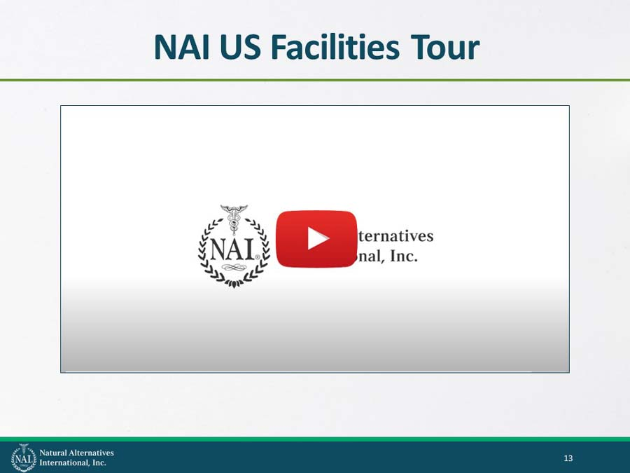

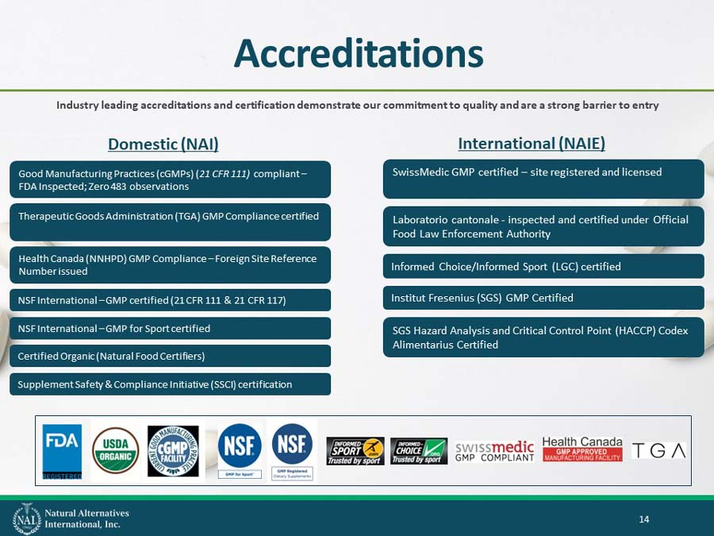

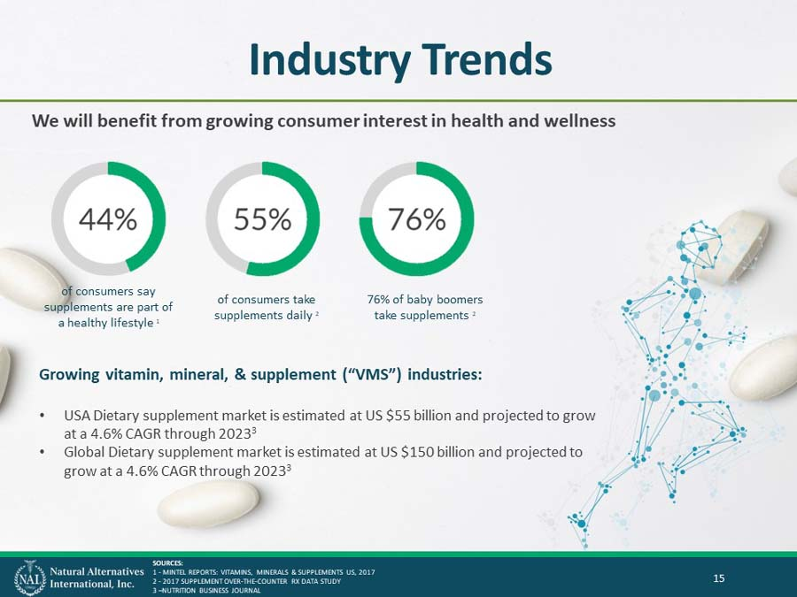

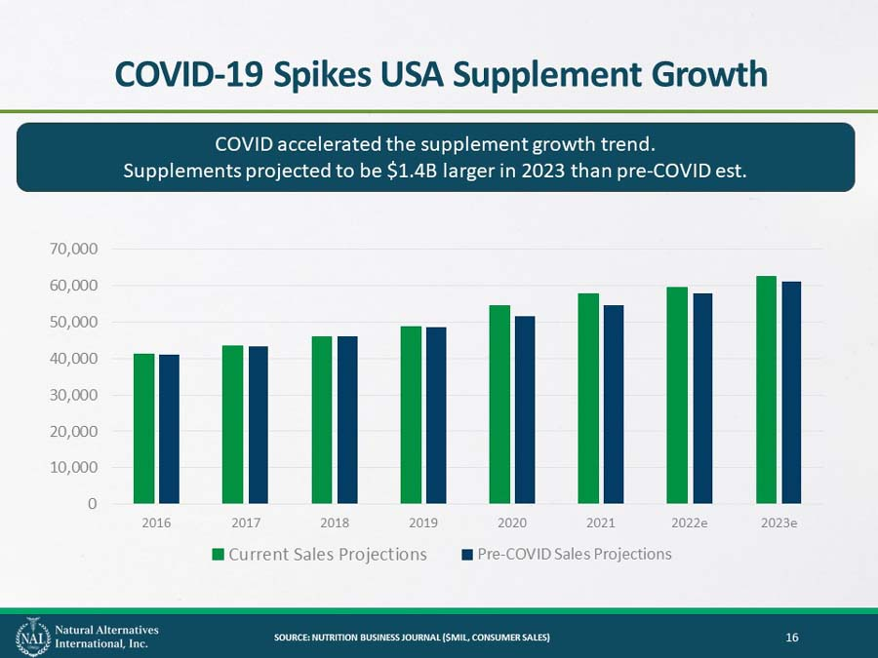

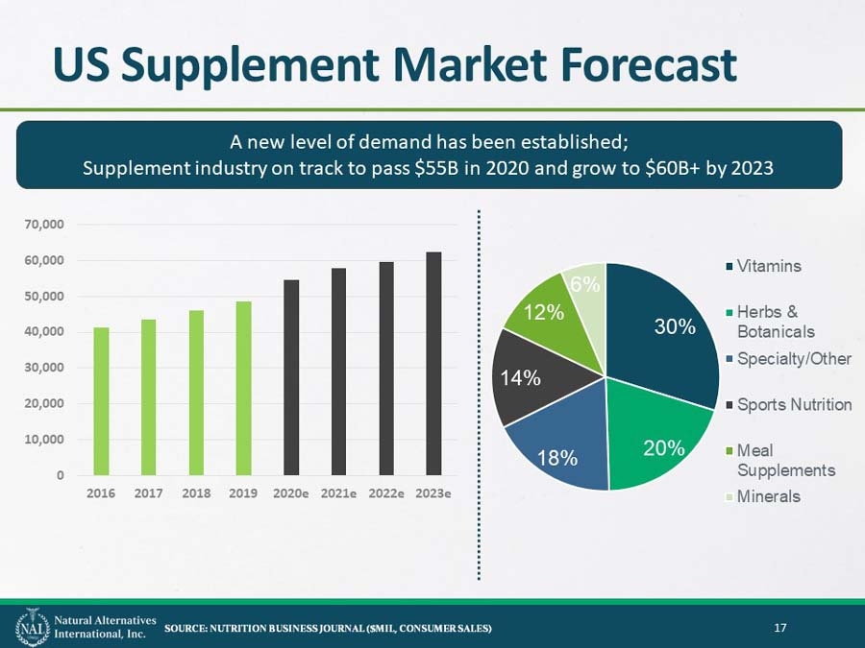

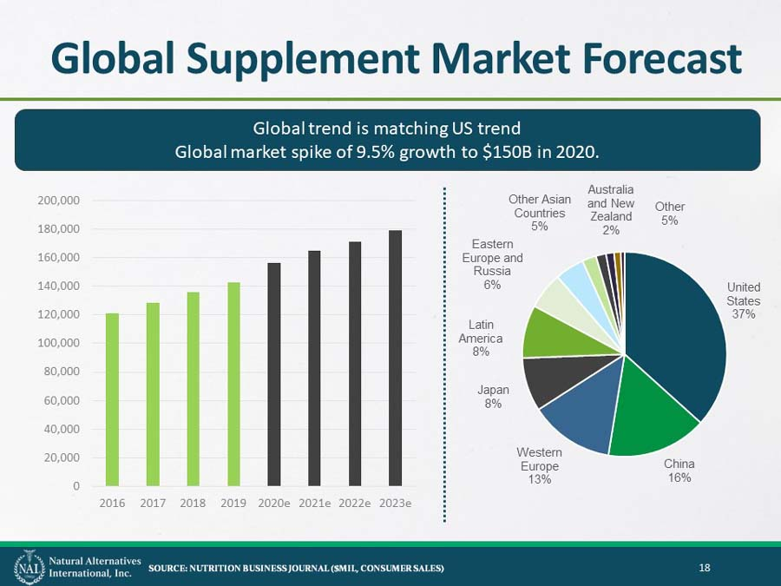



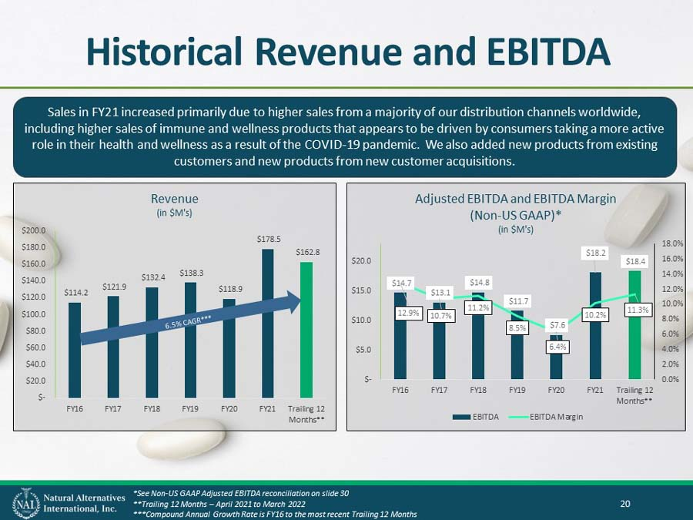

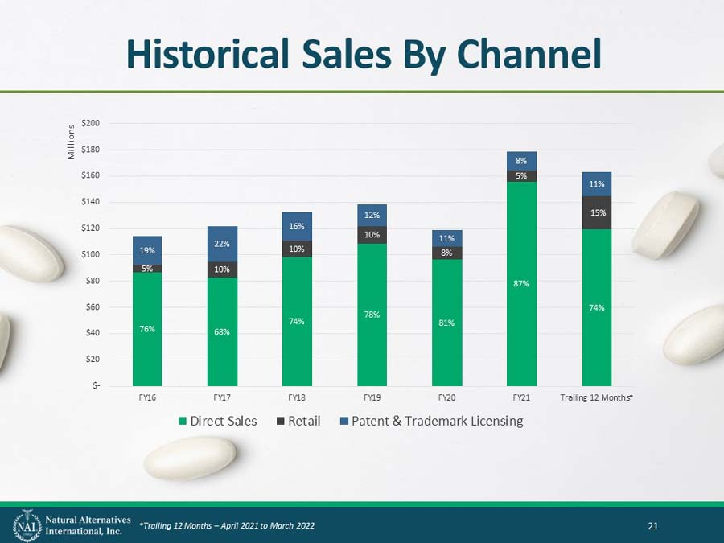

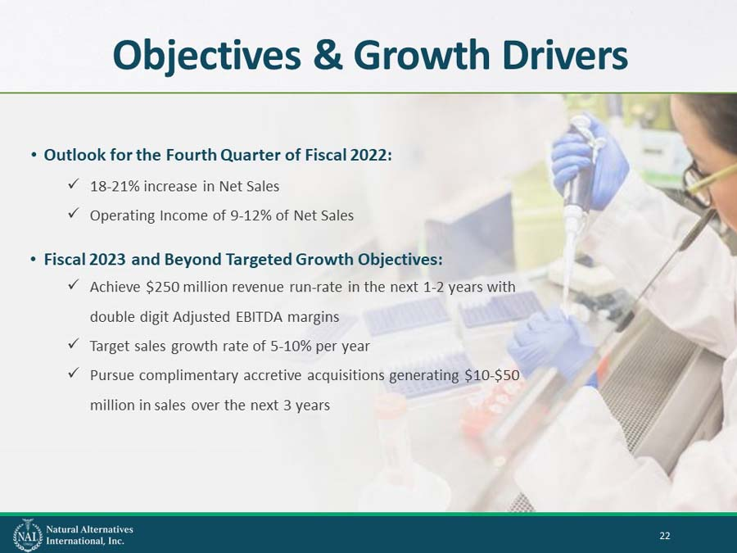

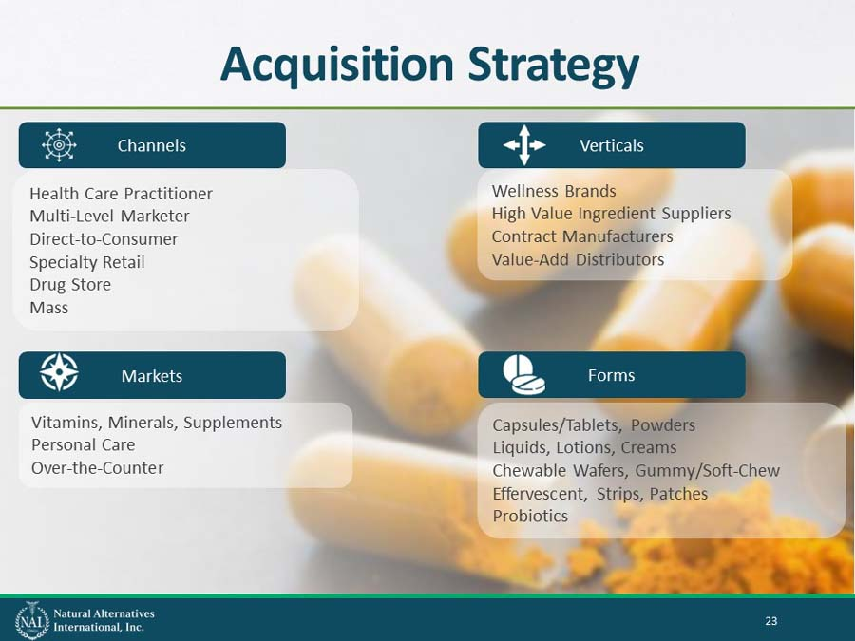

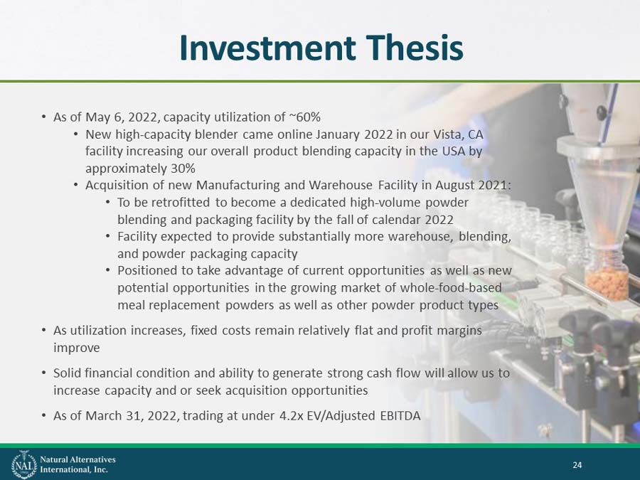

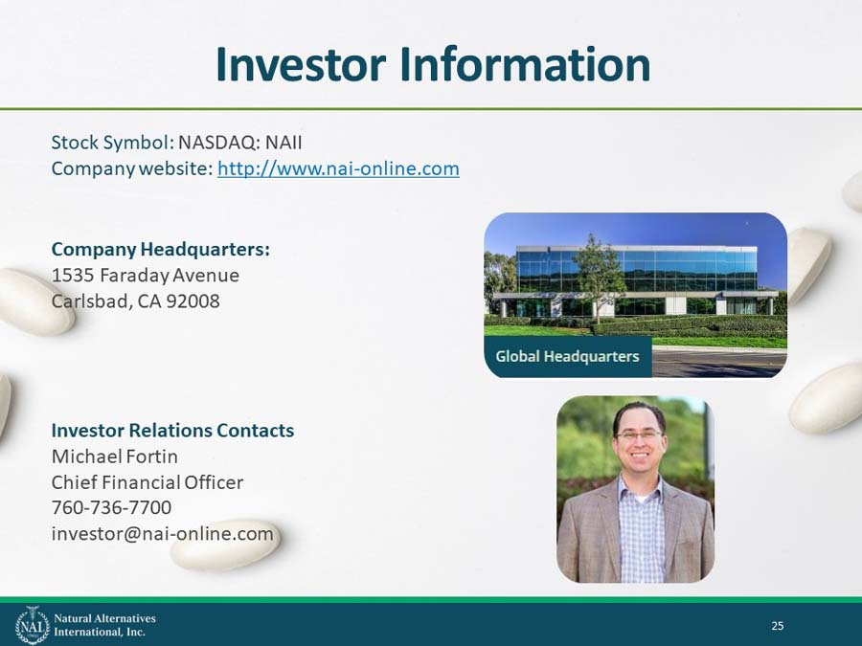



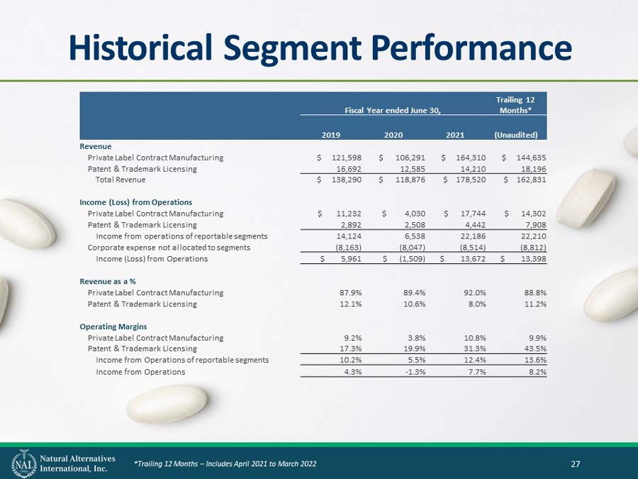

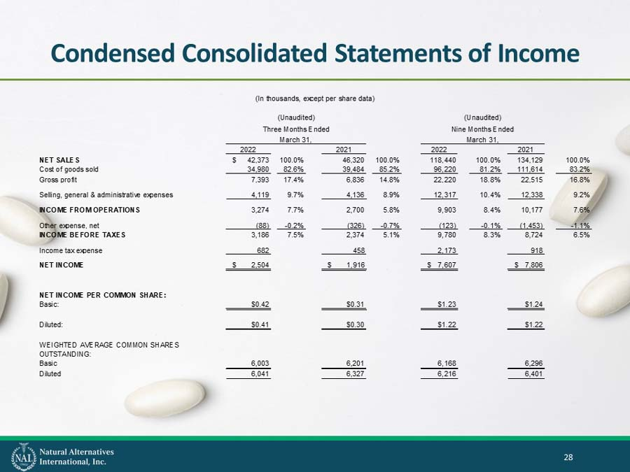

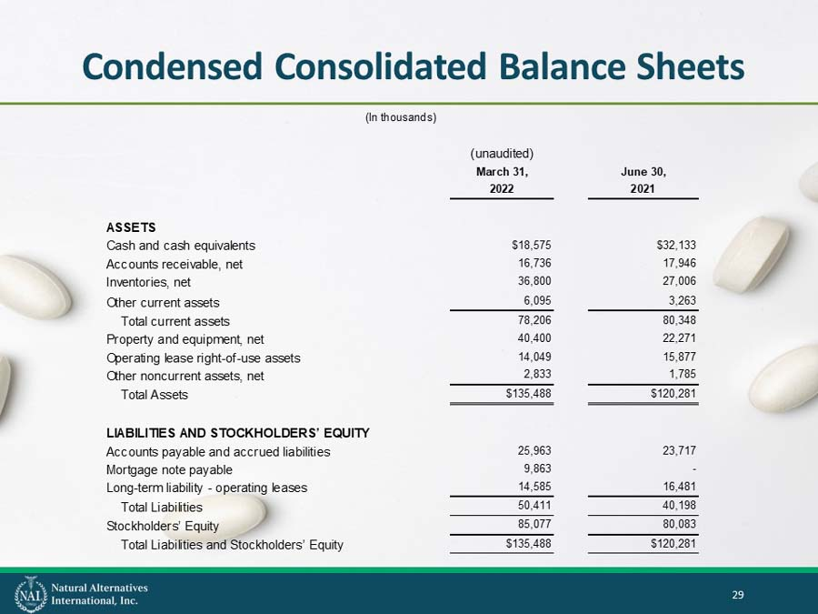

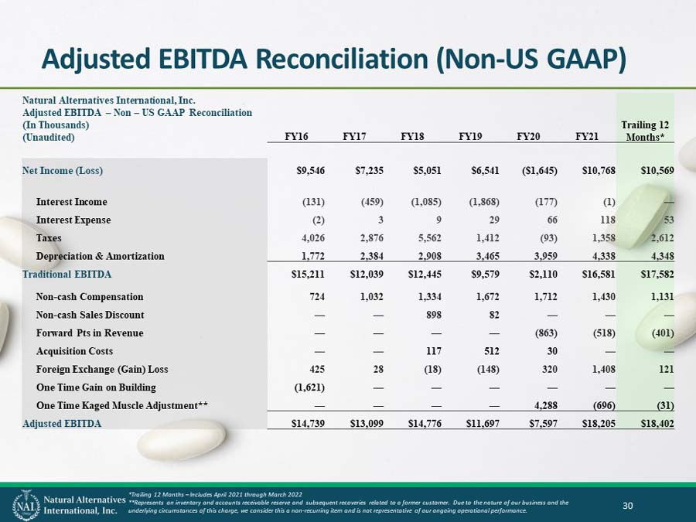



Exhibit 99.6



Natural Alternatives International, Inc.

Announces 2022 Q3 and YTD Results

● | 2022 Q3: Net Income Increased 30.7% and Diluted EPS Increased 36.7%

● | Q4 Fiscal 2022 Outlook: 18% - 21% Net Sales Increase

CARLSBAD, CALIF, May 13, 2022 /PRNewswire/ --Natural Alternatives International, Inc. ("NAI") (Nasdaq: NAII), a leading formulator, manufacturer, and marketer of customized nutritional supplements, today announced net income of $2.5 million, or $0.41 per diluted share, on net sales of $42.4 million for the third quarter of fiscal year 2022 compared to net income of $1.9 million, or $0.30 per diluted share, in the third quarter of the prior fiscal year.

Net sales during the three months ended March 31, 2022, decreased $3.9 million, or 8.5%, to $42.4 million as compared to $46.3 million recorded in the comparable prior year period. During the same period, private-label contract manufacturing sales decreased 10.8% to $37.6 million. Private-label contract manufacturing sales decreased primarily due to a 40% reduction in sales to our largest customer partially offset by sales to other existing customers and a new customer. Sales backlog for the quarter ended March 31, 2022 totaled approximately $10.0 million primarily related to supply chain issues, labor shortages, and logistical constraints.

CarnoSyn® beta-alanine royalty, licensing and raw material sales revenue increased 15.2% to $4.8 million during the third quarter of fiscal year 2022, as compared to $4.1 million for the third quarter of fiscal year 2021. The increase in patent and trademark licensing revenue during the third quarter of fiscal 2022 was primarily due to increased shipments to existing customers related in part to athletic activities and gyms reopening in accordance with easing COVID-19 restrictions across the USA as compared to significant restrictions in athletic activities primarily impacting the first nine months of fiscal 2021.

Net income for the nine months ended March 31, 2022 was $7.6 million, or $1.22 per diluted share, compared to net income of $7.8 million, also $1.22 per diluted share, for the nine months ended March 31, 2021. Net income for the first nine months of fiscal 2021 included a $0.9 million discrete tax benefit while the first nine months of fiscal 2022 did not have a corresponding discrete item.

Net sales during the nine months ended March 31, 2022 decreased $15.7 million, or 11.7%, from $134.1 million recorded in the comparable prior year period. For the nine months ended March 31, 2022, private-label contract manufacturing sales decreased $19.7 million, or 15.8%, from the comparable period last year. CarnoSyn® beta-alanine royalty, licensing and raw material sales revenue increased 41.7% to $13.5 million during the first nine months of fiscal 2022, as compared to $9.6 million for the first nine months of fiscal 2021.

Based on our current sales order volumes and forecasts we have received from our customers, and despite the continued challenges with supply chain and staffing shortages, including challenges from COVID-19 employee absences, we now anticipate our consolidated net sales during the fourth quarter of fiscal 2022 will increase between 18.0% to 21.0% as compared to the fourth quarter of fiscal 2021. We also anticipate operating income as a percent of net sales will increase to between 9.0% and 12.0% for our fourth quarter ending June 30, 2022. The improvement in net sales and operating profitability is expected to be generated from continued growth from one of our newest customers, improved sales demand from our largest customer, improved sales mix and improved staffing levels which will increase our production capacities.

As of March 31, 2022, we had cash of $18.6 million and working capital of $53.8 million, compared to $32.1 million and $58.3 million respectively, as of June 30, 2021. As of March 31, 2022, we had $20.0 million available under our line of credit agreement.

Mark A. Le Doux, Chairman and Chief Executive Officer of NAI stated, “Considering our ongoing staffing and supply chain challenges combined with a decline in sales from our largest customer, we are pleased with the results of our third quarter and first nine months of fiscal 2022. We successfully increased the capacity of our Vista California facility with the installation of a new high-capacity blender, which increased our throughput potential and enables us to better meet the demands of our customers while we continue construction on our new powder facility. While we were able to partially reduce our backlog going into the fourth quarter, demand remains strong, and we are continuing to add staff and navigate supply chain challenges. We expect to make significant strides to further reduce our backlog during our fourth quarter.”

“We will continue to utilize our robust balance sheet and free cash flow to drive shareholder value through both share buybacks and investments in our business. We continue to believe our stock is trading well below the true value of our Company.”

“I am proud of the efforts of our team as they have diligently navigated the mercurial landscapes of staffing and supply chain combined with the evolving needs of our clients. We still see significant opportunity for growth in both the near and long term and I believe the foundation we have laid over the past couple years will pave the way for future growth opportunities.”

An updated investor presentation will be posted to the investor relations page on our website later today (https://www.nai-online.com/our-company/investors/).

NAI, headquartered in Carlsbad, California, is a leading formulator, manufacturer and marketer of nutritional supplements and provides strategic partnering services to its customers. Our comprehensive partnership approach offers a wide range of innovative nutritional products and services to our clients including scientific research, clinical studies, proprietary ingredients, customer-specific nutritional product formulation, product testing and evaluation, marketing management and support, packaging and delivery system design, regulatory review and international product registration assistance. For more information about NAI, please see our website at http://www.nai-online.com.

This press release contains forward-looking statements within the meaning of Section 21E of the Securities Exchange Act of 1934 that are not historical facts and information. These statements represent our intentions, expectations and beliefs concerning future events, including, among other things, our ability to develop, maintain or increase sales to new and existing customers, our ability to attract and retain sufficient labor, COVID-19 and related impacts on the availability of raw materials, our future revenue profits and financial condition, as well as future economic conditions and the impact of such conditions on our business. We wish to caution readers these statements involve risks and uncertainties that could cause actual results and outcomes for future periods to differ materially from any forward-looking statement or views expressed herein. NAI's financial performance and the forward-looking statements contained herein are further qualified by other risks, including those set forth from time to time in the documents filed by us with the Securities and Exchange Commission, including our most recent Annual Report on Form 10-K.

SOURCE - Natural Alternatives International, Inc.

CONTACT – Michael Fortin, Chief Financial Officer, Natural Alternatives International, Inc., at 760-736-7700 or investor@nai-online.com.

Web site: http://www.nai-online.com

NATURAL ALTERNATIVES INTERNATIONAL, INC.
CONDENSED CONSOLIDATED STATEMENTS OF INCOME
(In thousands, except per share data)

 |  | (Unaudited) |  |  |  |  |  |  |  |  |  |  |  |  |  |  |  | (Unaudited)
 |  | Three Months Ended |  |  |  |  |  |  |  |  |  |  |  |  |  |  |  | Nine Months Ended
 |  | March 31, |  |  |  |  |  |  |  |  |  |  |  |  |  |  |  | March 31,
 |  | 2022 |  |  |  |  |  |  |  | 2021 |  |  |  |  |  |  |  | 2022 |  |  |  |  |  |  |  | 2021
NET SALES |  | $ | 42,373 |  |  |  | 100.0 | % |  |  | 46,320 |  |  |  | 100.0 | % |  |  | 118,440 |  |  |  | 100.0 | % |  |  | 134,129 |  |  |  | 100.0 | %
Cost of goods sold |  |  | 34,980 |  |  |  | 82.6 | % |  |  | 39,484 |  |  |  | 85.2 | % |  |  | 96,220 |  |  |  | 81.2 | % |  |  | 111,614 |  |  |  | 83.2 | %
Gross profit |  |  | 7,393 |  |  |  | 17.4 | % |  |  | 6,836 |  |  |  | 14.8 | % |  |  | 22,220 |  |  |  | 18.8 | % |  |  | 22,515 |  |  |  | 16.8 | %
Selling, general & administrative expenses |  |  | 4,119 |  |  |  | 9.7 | % |  |  | 4,136 |  |  |  | 8.9 | % |  |  | 12,317 |  |  |  | 10.4 | % |  |  | 12,338 |  |  |  | 9.2 | %
INCOME FROM OPERATIONS |  |  | 3,274 |  |  |  | 7.7 | % |  |  | 2,700 |  |  |  | 5.8 | % |  |  | 9,903 |  |  |  | 8.4 | % |  |  | 10,177 |  |  |  | 7.6 | %
Other expense, net |  |  | (88 | ) |  |  | -0.2 | % |  |  | (326 | ) |  |  | -0.7 | % |  |  | (123 | ) |  |  | -0.1 | % |  |  | (1,453 | ) |  |  | -1.1 | %
INCOME BEFORE TAXES |  |  | 3,186 |  |  |  | 7.5 | % |  |  | 2,374 |  |  |  | 5.1 | % |  |  | 9,780 |  |  |  | 8.3 | % |  |  | 8,724 |  |  |  | 6.5 | %
Income tax expense |  |  | 682 |  |  |  |  |  |  |  | 458 |  |  |  |  |  |  |  | 2,173 |  |  |  |  |  |  |  | 918
NET INCOME |  | $ | 2,504 |  |  |  |  |  |  | $ | 1,916 |  |  |  |  |  |  | $ | 7,607 |  |  |  |  |  |  | $ | 7,806
NET INCOME PER COMMON SHARE:
Basic: |  | $ | 0.42 |  |  |  |  |  |  | $ | 0.31 |  |  |  |  |  |  | $ | 1.23 |  |  |  |  |  |  | $ | 1.24
Diluted: |  | $ | 0.41 |  |  |  |  |  |  | $ | 0.30 |  |  |  |  |  |  | $ | 1.22 |  |  |  |  |  |  | $ | 1.22
WEIGHTED AVERAGE COMMON SHARES OUTSTANDING:
Basic |  |  | 6,003 |  |  |  |  |  |  |  | 6,201 |  |  |  |  |  |  |  | 6,168 |  |  |  |  |  |  |  | 6,296
Diluted |  |  | 6,041 |  |  |  |  |  |  |  | 6,327 |  |  |  |  |  |  |  | 6,216 |  |  |  |  |  |  |  | 6,401

NATURAL ALTERNATIVES INTERNATIONAL, INC.
CONDENSED CONSOLIDATED BALANCE SHEETS
(In thousands)

 |  | (unaudited)
 |  | March 31, |  |  |  | June 30,
 |  | 2022 |  |  |  | 2021
ASSETS
Cash and cash equivalents |  | $ | 18,575 |  |  | $ | 32,133
Accounts receivable, net |  |  | 16,736 |  |  |  | 17,946
Inventories, net |  |  | 36,800 |  |  |  | 27,006
Other current assets |  |  | 6,095 |  |  |  | 3,263
Total current assets |  |  | 78,206 |  |  |  | 80,348
Property and equipment, net |  |  | 40,400 |  |  |  | 22,271
Operating lease right-of-use assets |  |  | 14,049 |  |  |  | 15,877
Other noncurrent assets, net |  |  | 2,833 |  |  |  | 1,785
Total Assets |  | $ | 135,488 |  |  | $ | 120,281
LIABILITIES AND STOCKHOLDERS’ EQUITY
Accounts payable and accrued liabilities |  |  | 25,963 |  |  |  | 23,717
Mortgage note payable |  |  | 9,863 |  |  |  | -
Long-term liability - operating leases |  |  | 14,585 |  |  |  | 16,481
Total Liabilities |  |  | 50,411 |  |  |  | 40,198
Stockholders’ Equity |  |  | 85,077 |  |  |  | 80,083
Total Liabilities and Stockholders’ Equity |  | $ | 135,488 |  |  | $ | 120,281

